11.46: a) Denote the weight per unit length as
The center of gravity is a distance 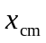to the right of point O where

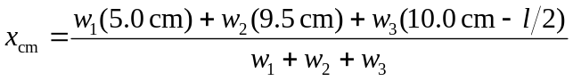

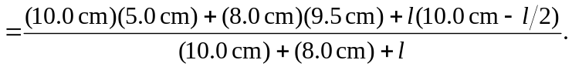

Setting 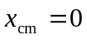 gives a quadratic in which has as its positive root 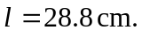
b) Changing the material from steel to copper would have no effect on the length since the weight of each piece would change by the same amount.

